Petroglyph Little League, Inc.
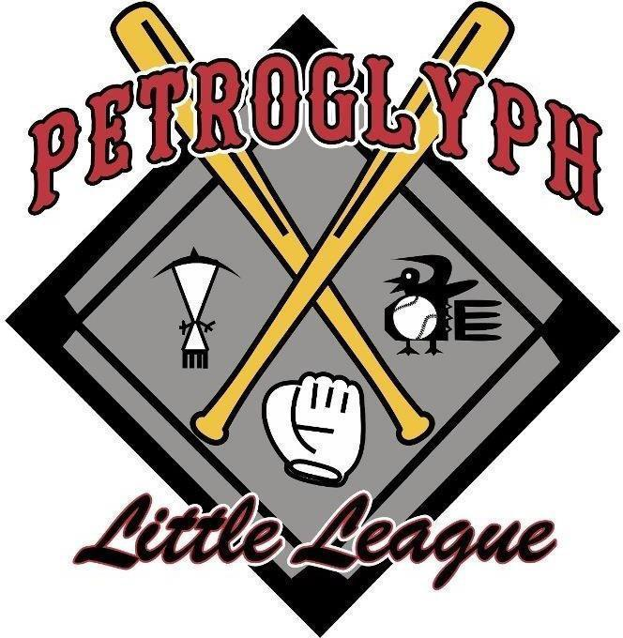
A.S.A.P.

“A Safety Awareness Program”
Petroglyph Little League has adopted the following Safety Plan for the safety of our players, coaches, volunteers and parents. This plan has been prepared using the guidelines from the ASAP literature on “A Qualified Little League Baseball® Safety Program”.
Safety Officer: Graham Miller
League ID: 431-08-10
City: Albuquerque, New Mexico
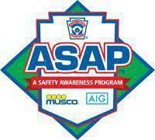
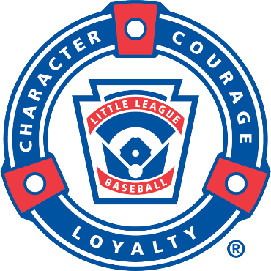
“Play Hard - Play Safe - Have Fun”

ASAP Plan

Safety Officer
Graham Miller is the active Safety Officer for Petroglyph Little League (PLL) for Fiscal Year 2024. The Safety Officer holds an Executive Board Member position within the Petroglyph Little League (Albuquerque, New Mexico, USA).

Team Safety
All teams will have a first-aid kit available and fully stocked at all practices and games. A cell phone is available at all practices and games for emergency purposes. Managers are also required to carry all medical release forms of their players at both the games and all practices.

Safety Manual
The Safety Officer has prepared a Safety Manual for the managers, board members and other volunteers. This manual includes our safety code, emergency procedures and phone numbers, as well as our league safety guidelines. This plan will be distributed to the managers, Board members, District Safety Officer and other volunteers as applicable. It will be posted in the concession stand for general availability.

Volunteer Applications
Volunteer application forms must be filled out for all league Volunteers, no matter the capacity in which the individual fills. League Volunteers include all members of the Board of Directors.

Background Checks
Background checks will be conducted for key volunteers such as managers, coaches, concession monitors, Board Members and other league volunteers who are in recurring contact with the players. The background investigation includes a check for sex offenders.

Training

Petroglyph Little League has focused on developing a “safety mindset” not only for our players and coaches, but for everyone affiliated with the league, including volunteers, spectators and guests. Managers are REQUIRED to attend instructional courses in first aid, as well as a clinic on the coaching of fundamental baseball skills. These clinics and seminars are also available to ALL LEAGUE VOLUNTEERS.
First Aid
Each manager is required to attend the pre-season Emergency Management Training Program (usually held at the Mandatory Manager’s Meeting) prior to the Season. Coaches and umpires are strongly encouraged to attend and all league members are welcome. This training is conducted by qualified medical professionals, usually from within our league or community. As part of the training all attendees receive information on basic first aid, with an emphasis on heat-related illness along with proper hydration and concussion. They are also given instruction on injury prevention by implementing effective warm-up routines.
Coaches and Volunteers are also required to take the Heads Up online concussion awareness training at: https://www.cdc.gov/headsup/youthsports/training/index.html
And the Heads Up Heat Related Illness training at: https://www.cdc.gov/nceh/hsb/extreme/Heat_Illness/index.html

Fundamentals
Every manager is required to attend training on proper mechanics and fundamental baseball techniques. Managers are encouraged to pass this training on to their coaches, players and parents. Safety concerns are focused upon and reiterated.
Umpire clinic
Volunteers who have an interest in umpiring are strongly encouraged to attend this clinic. Little League rules are examined, with the emphasis placed on keeping the games safe and enjoyable for everyone.
Concession Sanitation
Petroglyph conducts annual training seminars for our concession stand managers and monitors. Local restaurant operators or others knowledgeable on the subject of food handling sanitation and environmental health requirements will provide instruction on

sanitation and proper food handling procedures; with an emphasis on prevention of food- born illness. Concession work-area safety will also be covered. All procedures will be clearly posted within the concession trailer.

Facilities and Equipment

Facilities
Each manager is required to “walk the fields” prior to practices and games to ensure the field is safe for play. All potential hazards must be corrected before play can begin. Umpires are required to participate in this inspection prior to the start of each game. Any new hazards or concerns are to be reported to the League Safety Officer or Field Monitor.
Equipment
All equipment will be inspected prior to being issued to each team by the League Equipment Manager. Each piece of equipment will meet Little League standards. Managers and umpires are required to inspect all equipment prior to games. Any damaged or faulty equipment must be replaced immediately. Equipment that cannot be repaired must be thrown away in a manner to prevent it from being “saved” and reused by anyone.
Ambulance Accessibility
No parking is EVER allowed in front of the main walkway to our fields. The curbs are painted RED to prevent parked vehicles from blocking access for ambulances, fire trucks and other emergency vehicles. A key will be available in the concession stand for unlocking the yellow bollards that prevent vehicle access to the walkway to the fields from the beginning of practice in March through the end of the All-star tournament. Ambulances MUST have an unobstructed path to each and every field, at all times! The Field Monitor will make sure this path is clear. UNAUTHORIZED VEHICLES WILL BE TOWED AT OWNERS’ EXPENSE!
Parking Lot Safety
Parking lot safety is not only for the little league players…. but soccer, football, basketball and other youth activities as well that are conducted at our park. We must always use caution when entering or exiting the parking lot. Watch out for youngsters running from behind vehicles. Keep your own children at your side in the parking lot. Do not “drop off” your players in front of the red parking zone. This obstructs the flow of traffic and causes unnecessary back-ups at the entrance. This can be dangerous as well as frustrating. Please

4 | P a g e
arrive with enough time to park safely, and then WALK to the baseball fields. Children are
everywhere… WATCH FOR THEM!
Field Monitors and Lightning Policy
Written safety procedures are available in the concession stand. Included are the Safety Code, and these general safety guidelines. As part of our focus on providing a safe playing environment, we require board members to serve as Field Monitors during all games and events. Among their duties is to monitor the weather and work with umpires to provide a safe environment for players and spectators. In the event of lightning registered from 8 miles on our lightning detection meter, all play will stop and players and spectators will be sent to their vehicles or other approved lightning shelter until any danger has passed. Play will not resume until the Field Monitor, umpires and managers agree it is safe, no less than 30 minutes from the last recorded lightning strike within 8 miles. The Field Monitor will also monitor and maintain ambulance accessibility.
Concession Managers
Concession Managers are required to know and understand safe food handling procedures. Sanitation and work area safety will be their key points of focus. See attached Operational & Food Safety Manual with Food Safety Check List.
Telephone Access
The field monitors will have a cellular phone and will be at the field in case of emergency at all times. Team safety coordinators (usually the team parent) will make sure at least one cell phone is present at all practices and games. Managers are instructed at the mandatory managers meeting to make sure Someone has a working cell phone at all practices and games.
Little League Rules
All Little League rules, including equipment regulations, will be strictly enforced. Every manager will be provided with the Official Rule and Regulations book for their respective divisions before the start of the season and be required to have it with them at all games and practices. catcher’s gear and helmet rules will be strictly enforced. Adults may NOT warm up or catch for a pitcher. Bases that disengage from their anchors will be used on all fields.
Field/Facility Survey
A field/facility Survey was completed on 11/04/2023 with the District 8 Safety Officer. He gave us the go ahead to complete our Charter for the 2024 season. Safety concerns that were noted and being address are:
- The fencing in the Jr./Sr. field
- The fencing in the Majors field
PLL is working with the city of ABQ to secure funding for fencing issues throughout the little league.

Activities

Bicycle, Skateboard and Rollerblade Policy
For the duration of all Little League activity, our local rules require that all bicyclists and skateboarders WALK through areas of congestion. Roller-bladers will be required to skate at a pace no faster than those around them.
Accident Reporting/Tracking
Each manager is required to provide the Safety Officer with an accident report of ALL incidences within 48 hours of the incident. The Safety Officer will provide the appropriate reporting forms and have them readily available, usually located in the concession stand. “Near-misses” must be tracked and used as a tool to evaluate practices and to limit potential future injury.
First Aid
Well-equipped, Little League-sanctioned first aid kits will be issued to every team in the league. Managers will be required to bring the kits to all practices and games and will be required to keep them readily accessible and sufficiently stocked. Replacement items, such as adhesive bandages and instant cold packs will be available from the Safety Officer. In addition to the individual team safety kits, the League will keep a larger first aid kit in the concession stand.
Alcohol and Tobacco
The use of any alcohol or tobacco product is EXPRESSLY PROHIBITED! This includes chewing tobacco, vapes and E-cigs.
Mouth Guards
The proper use of mouthguards can greatly reduce the chances of injury to the mouth and gums. The use of mouth guards is highly recommended by the League, but not required
Sunset Rule
All games (including Junior/Senior Baseball) will end at SUNSET. NO EXCEPTIONS! Sunset times will be in accordance with the day of play as instructed by the field monitor.

Petroglyph Little League
Safety Code
“Dedicated to Injury Prevention”

- Responsibility for procedures should be that of an adult member of the League.
- Arrangements should be made in advance of all practices and games for emergency medical services.
- Managers, coaches, and umpires should have training in first aid. A first aid kit MUST be available at every field.
- No practices or games should be held when weather or field conditions are unsafe, particularly under inadequate lighting conditions.
- Fields should be inspected frequently for holes, damage, stones, glass or other foreign object hazards.
- Dugout benches, bat and helmet racks should be placed behind screens, out of play.
- Only players, managers and coaches are allowed on the playing field or in the dugout during play and practice sessions.
- Responsibility for keeping bats and loose equipment off the field of play should be that of a helmeted player assigned for this purpose.
- Procedure should be established for retrieving foul balls out of play.
- During practice and games, all players should be alert and watching the batter on every pitch.
- During warm up drills, players should be positioned so as to minimize endangerment from wild throws or missed catches.
- All equipment should be inspected regularly for condition and proper fit.
- Batters MUST wear approved helmets during practice and games.
- Catchers MUST wear a catcher's helmet, mask, dangling-type throat guard, long model chest protector and shin guards. Male catchers must wear protective supporters or cups. NO EXCEPTIONS.
- Headfirst sliding is NOT PERMITTED (except when returning to base.)
- During slide practice, bases should not be anchored.
- No “horse play” permitted at any time on the field.
- Parents of children with glasses are encouraged to provide “safety glasses.”
- NO JEWELRY WHATSOEVER! Including pins, watches, rings or metallic items. EXCEPTION - medical condition alert insignia.
- Catchers MUST wear helmet, mask and throat guard during any warm up activity including the bullpen.
- On-Deck batters are not permitted. EXCEPTION - JR/SR Division.
*See a need to add to our Safety Code? Contact: PLL Safety Officer

Petroglyph Little League Emergency Contacts

Emergency Phone Numbers
Police, Ambulance, Fire 911
Taylor Ranch Fire Station 505-897-8810
(Directly across from P.L.L. fields, but call 911 for emergency)
Emergency Room Numbers and Addresses Lovelace Westside Hospital 505-727-2000
10501 Golf Course Rd NW (north on Golf Course then west on McMahon, immediate
right)
Presbyterian Hospital 505-841-1234
1100 Central SE (one block east of I-25 on the south side of Central)
University of New Mexico Hospital 505-272-2111
2211 Lomas Blvd. NE (several blocks east of University Blvd on the north side of Lomas)
Presbyterian Rust Medical Center 505-253-7878
2400 Unser Blvd SE, Rio Rancho (Unser, North of McMahon)

When in doubt of severity of injury, please call 911

Petroglyph Little League Concession Trailer Safety

- Always Refer to the Operational & Food Safety Manual with Food Safety Check List
- Always wash hands before (and during) concession duty.
- Use hair restraint when necessary.
- Use disposable plastic gloves when handling food.
- No eating or drinking while in the concession stand!
- Communicable disease procedure: Do not handle food while ill.
- Wash, rinse and sanitize all equipment, utensils and work surfaces after use. This helps prevent cross-contamination.
- Monitor all food temperatures diligently. See Guidelines below.
- Remember to ROTATE inventory - Use FIFO (first in, first out!)
- Watch out for hot surfaces!
- Use caution when handling sharp knives.
Temperatures
Temperature Guidelines
- All prepared foods must be held at 145ºF or above.
- All refrigerated items must be held below 40ºF.
- All frozen items must be held below 32ºF.
- Temperatures must be continually monitored!

REMEMBER the food temperature DANGER ZONE...
40º F to 140º F.
Any refrigerated or cooked foods that have had prolonged exposure to this temperature range must be discarded.

Key phrase:
When in doubt, Throw it out!

Petroglyph Little League COVID-19 Safety Protocols
- Petroglyph Little League will follow all recommended Guidelines from the:
- Center for Disease Control and Prevention (CDC)
- State Of New Mexico’s Public Health Department
- City of Albuquerque Public Health Orders

Petroglyph Little League Training Clinics and Dates
Fundamentals Training

Instruction on sliding, hitting, fielding and throwing. Managers or coaches required to attend. All volunteers are welcome, but every team MUST send a manager or coach.

TBD

First-Aid Training

Instruction on first aid. Managers or coaches required to attend. All volunteers are welcome, but every team MUST send a manager or coach.

TBD

Concession Safety Training

Instruction on proper food handling methods, sanitation and safe work methods. All Concession Managers REQUIRED to attend.

TBD

Umpire Training Clinics

Regional Umpire Clinic: February 23-25th
Local Umpire Clinic: TBD
Date: Multiple Dates and Locations, check www.petroglyphll.org.

Scorekeepers Clinic

Tips on keeping an accurate book. A must for those moving from Minor Machine-pitch to Minor Player- pitch. All are welcome. Tentative based on request

Petroglyph Little League Board Members 2024/2025

President | Bill Waller | 505-489-8327
Vice President | Julian Murrieta | 505-550-4703
Chief Umpire | Carlos Segura | 505-490-2756
Secretary | Brandy Bonsall | 505-737-9172
Treasurer | Carlos Segura | 505-490-2756
Player Agent | Chris Cordes | 949-677-5108
Website/Information Manager | Shane Boyce | 505-506-4546
Sponsorship Director | Adrian Montoya | 505-610-8008
Field Maintenance Manager | Graham Miller | 505-259-5556
Uniform Manager | Jesse Hale | 505-688-9591
Equipment Manager | Vince Lovato | 505-755-4171
Concession Manager | Nicole Wilson | 909-921-5436
Safety Officer | Graham Miller | 505-259-5556
T-Ball Commissioner | Cacy Shultz | 505-933-0950
Rookies BB Commissioner | Cacy Shultz | 505-933-0950
Minor Baseball Commissioner | Josh Dunn | 214-907-2302
Major Baseball Commissioner | Josh Dunn | 214-907-2302
Softball Commissioner | Clint Miller | 505-452-6413
Junior/Senior Commissioner | TBD | TBD

Safety Plan Checklist

- Have correctly stocked first aid kits available at each equipment connex
- Field monitors will have cell phones at fields at all times
- Background checks conducted on all key volunteers

